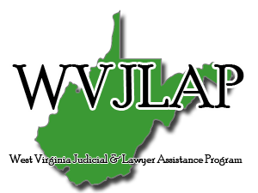

2019 WVJLAP Retreat Agenda
Friday, April 12th: Arrival
6:00p.m. Open Board Meeting, Dinner provided at Stillwaters
8:00 p.m. Twelve Step Open Meeting
Saturday, April 13th:
8:00 a.m. to 9:00 a.m. Breakfast at Stillwaters
9:00 a.m. to 9:50 p.m. Attorney Wellness Presentation; Yvette Hourigan, Executive Director of the Kentucky Lawyer Assistance Program. (1 CLE)
10:00 a.m. to 11:50 a.m. Practice Better, Feel Better, Be Better;
Brenda Waugh & Elliot Hicks (2 CLEs)
12:00 p.m. to 1:00 p.m. Lunch at Stillwaters
1:00 p.m. to 6:00 p.m. Free Time for Networking, Golf, and other Park Activities
7:00 p.m. to 8:30 p.m. Banquet (Speaker Dante’ diTrapano) (1 CLE)

Sunday, April 14th:
8:00 a.m. – 9:00 a.m. Breakfast at Stillwaters
9:00 a.m. – 10:00 a.m. Ann Bostic, CRNA; American Association of Nurse
Anesthetists, Regional Advisor for the AA/NA Wellness/Peer Assistance Committee (1 CLE)
10:00 a.m. – 11:00 a.m. Life Coaching/WVJLAP Volunteer Training (Large Conference Room) (1 CLE)
10:00 a.m. – 11:00 a.m. Recovery Trek Participant Training (Small Conference Room)

