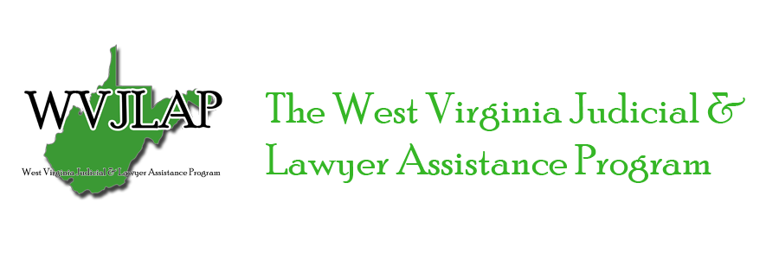2021 WVJLAP Retreat Agenda

Stonewall Resort, Roanoke WV

Friday, May 14th
6:00 pm  8:00 pm | Board Meeting  Friends of Bill & Lois W.

Saturday, May 15th
8:00 am to 9:00 am | Registration & Continental Breakfast
8:45 am to 9:00 am  9:00 am to 9:50 am | Opening Remarks by Justice Beth Walker of the West Virginia Supreme Court of Appeals  “ASAM Safety Sensitive Workers & Best Practices”; Buddy Stockwell, Esq.,
 | Executive Director of the Tennessee Lawyers Assistance Program
10:00 am to 11:50 am | “Decide to Thrive: The Case for Lawyer Well-Being”; Julie Krolczyk, Esq.,
 | Health & Life Coach
12:00 pm to 1:00 pm | Break for Lunch
1:00 pm to 6:00 pm | Free Time for Networking, Golf, and other Park Activities
7:00 pm to 8:30 pm | Banquet (Speaker Laurie Besden, Esq., Executive Director of Pennsylvania
 | Lawyers Concerned for Lawyers)

Sunday, May 16th
8:00 am to 9:00 am | Registration & Continental Breakfast
9:00 am to 10:00 am | “The Self-Compassion Solution to Job Burnout”; Stephanne Thornton, MSW,
10:00 am to 11:00 am | Criminal Justice Specialist for WV Public Defender Services  WVJLAP Volunteer Training, Robert Albury, J.D., LADC WVJLAP  Executive Director and Buddy Stockwell, Esq., TLAP Executive Director

