2019 WVJLAP Annual Conference & Retreat Registration
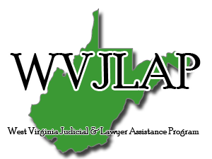
The West Virginia Judicial & Lawyer Assistance Program Conference & Retreat is the ideal venue to reconnect with lawyers and friends, and to build new relationships, while enjoying Stonewall Resort. Take advantage of the all-inclusive rate offered to our participants, which includes two (2) night accommodations, registration for the conference, five (5) hours of Ethics CLEs, and all meals from Friday evening to Sunday morning! All members of the bench, bar and their families who support or are interested in supporting the mission of WVJLAP are invited to join us at Stonewall Resort in Roanoke, West Virginia for a weekend CLE conference, volunteer training, open board meeting, banquet, and networking opportunity.
When: April 12th, 2019 through April 14th, 2019
Location: 940 Resort Drive
Roanoke, WV 26447
Event Fees: Includes 2 nights lodging, five meals, banquet attendance, and CLE Conference Registration
Name Email Phone County Special Food
Accommodations Allergies
*Please send registration to hanna@wvjlap.org, or fax to (304) 553-7232.

