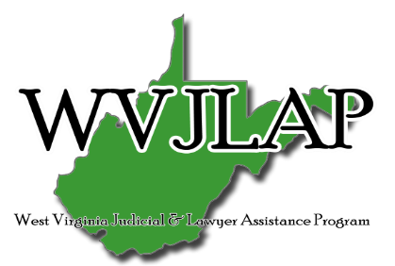
BARCAST
“The best way to predict your future is to create it.”
- Abraham Lincoln

Crossing Over
Successful in every respect, this lawyer managed his drinking for years. When the imaginary line was crossed and his drinking became unmanageable, he sought help through WVJLAP before facing major consequences. The unexpected results of his recovery became a priceless gift. Read More

Only a Cultural Shift Can Improve Substance Abuse and Mental Health Problems in the Legal Profession
Read Article

Resilience in the Practice of Law
Put in summary of Julie’s article. Read More

New Well-Being Template for Legal Employers
The ABA Commission on Lawyer Assistance Programs (CoLAP) and the ABA Working Group to Advance Well-Being in the Legal Profession developed this template to provide suggested guidelines to legal employers for responding to an employee who is experiencing impairment due to a substance use disorder, mental health disorder or cognitive impairment.

You’re in a pickle. Can a lawyer assistance program help?
Bree Buchanan discusses how lawyer assistance programs work, and how a person can reach out for assistance. Listen to podcast

